**DECISION TREE**

**CSE 303: Machine Learning**

Submitted by

Name: Guntur Ridhi

Roll No: AP22110011467

Section: CSE M

Lab Date: 10/09/2024

Submission Date: 16/09/2024

**Department Computer Science and Engineering**

**School of Engineering and Sciences**

**SRM University–AP**

**Amaravati, Andhra Pradesh – 522 240, India**

1. **Question**

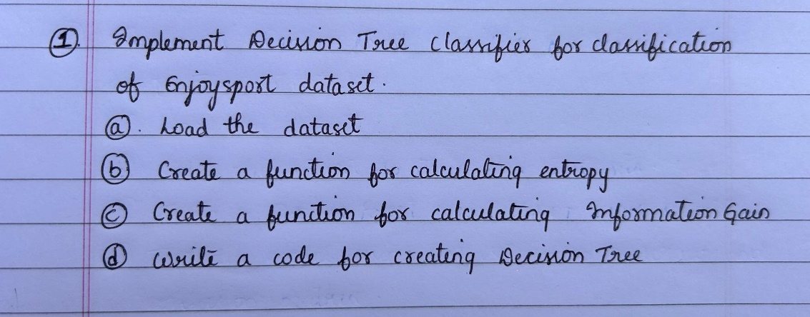

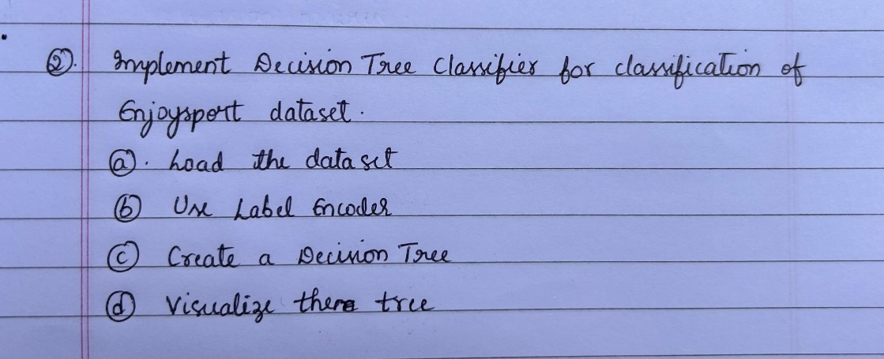

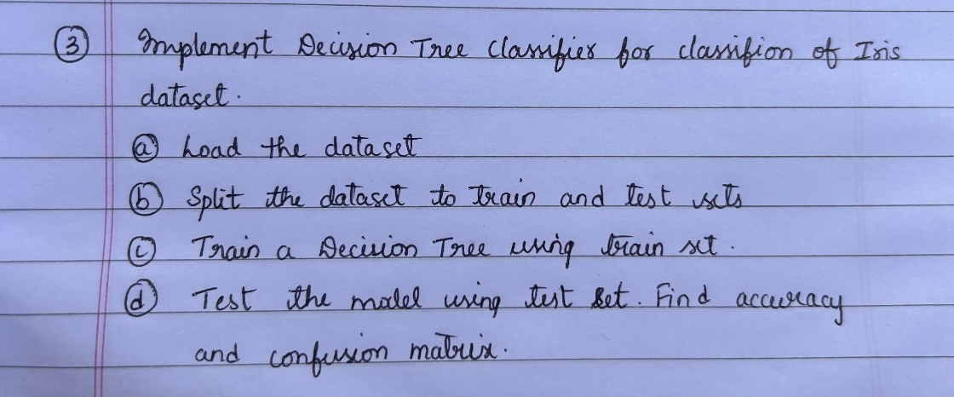

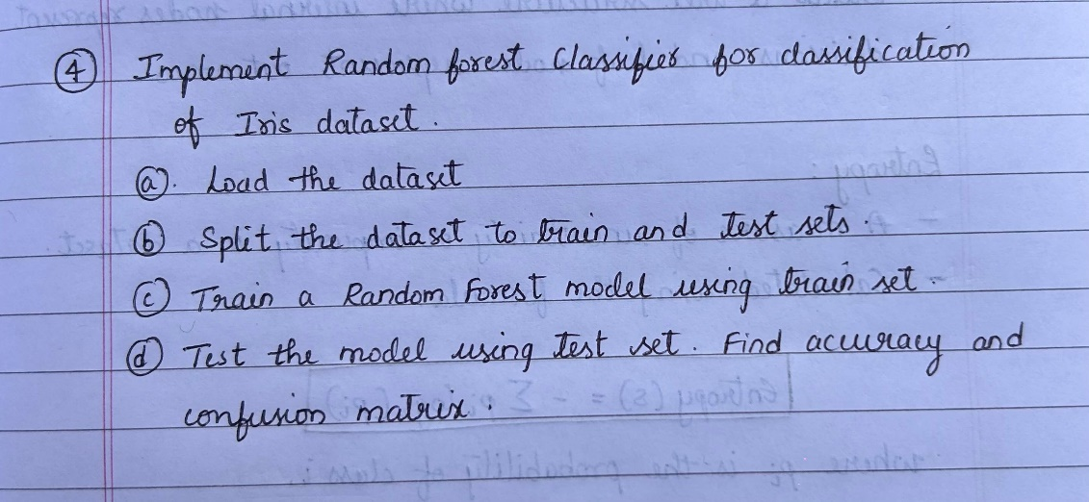

1. **Algorithm Description**

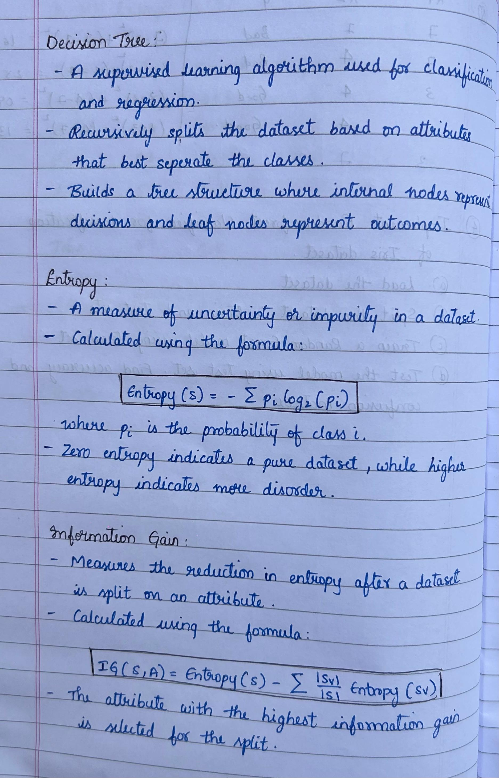

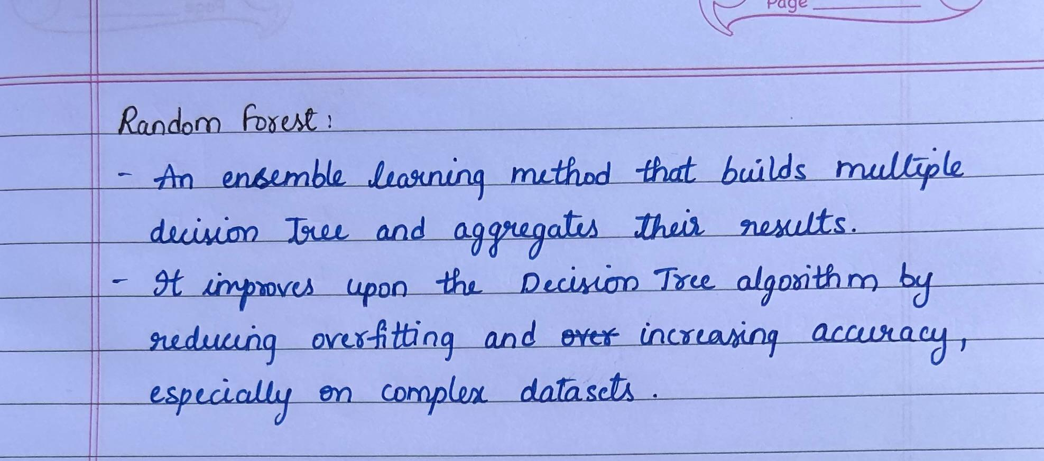

1. **Solution**

**QUESTION:1**

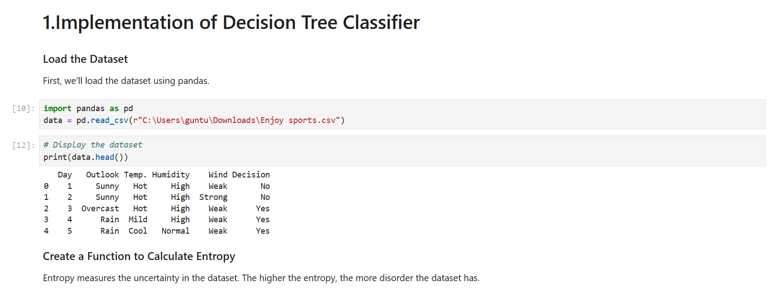

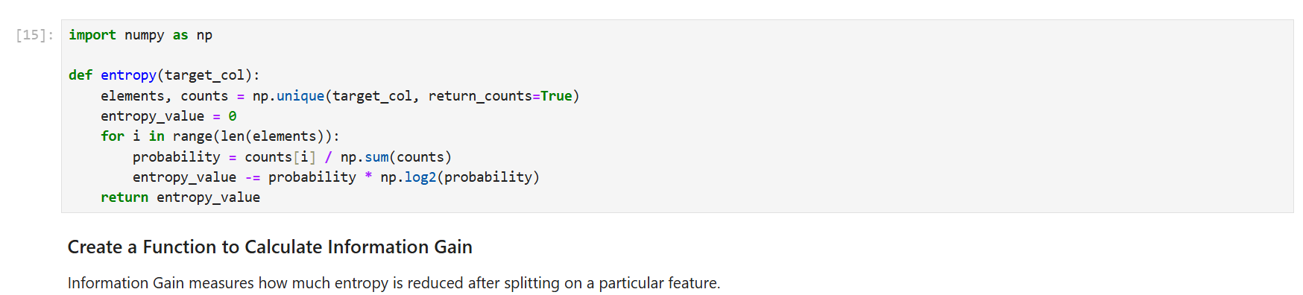

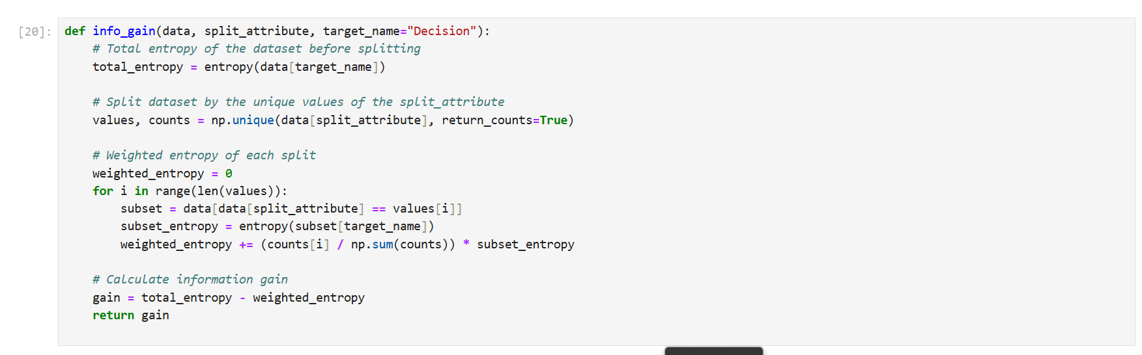

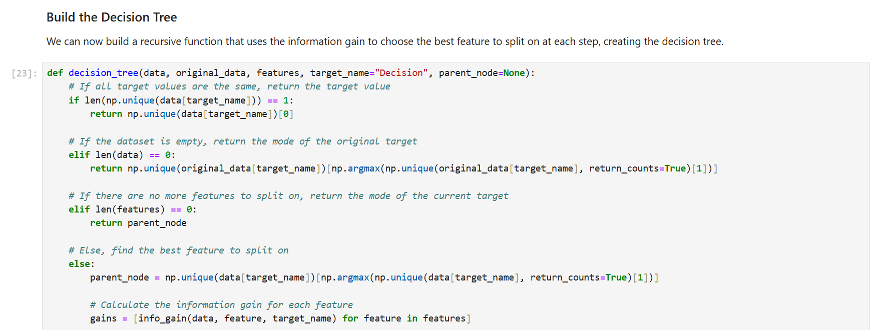

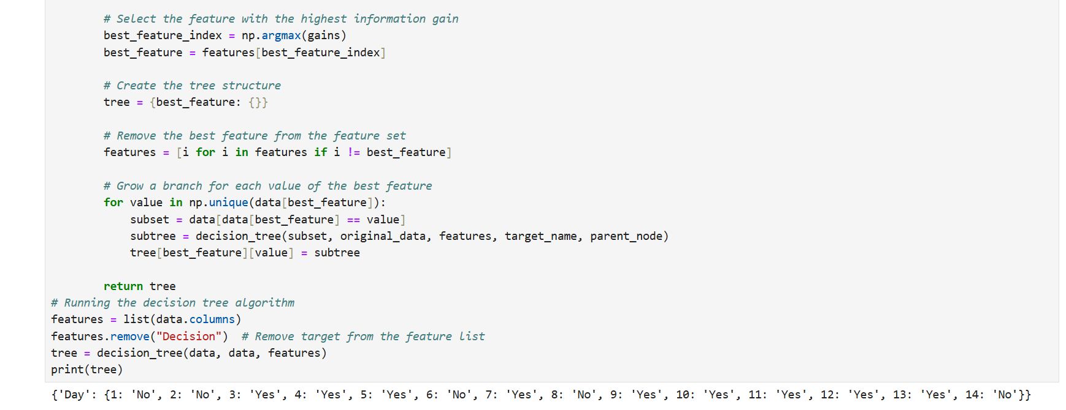

**QUESTION:2**

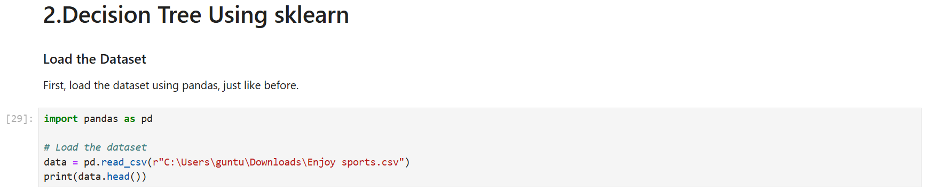

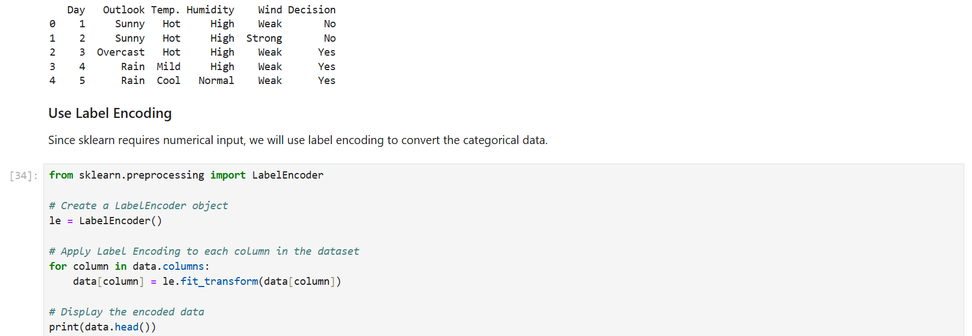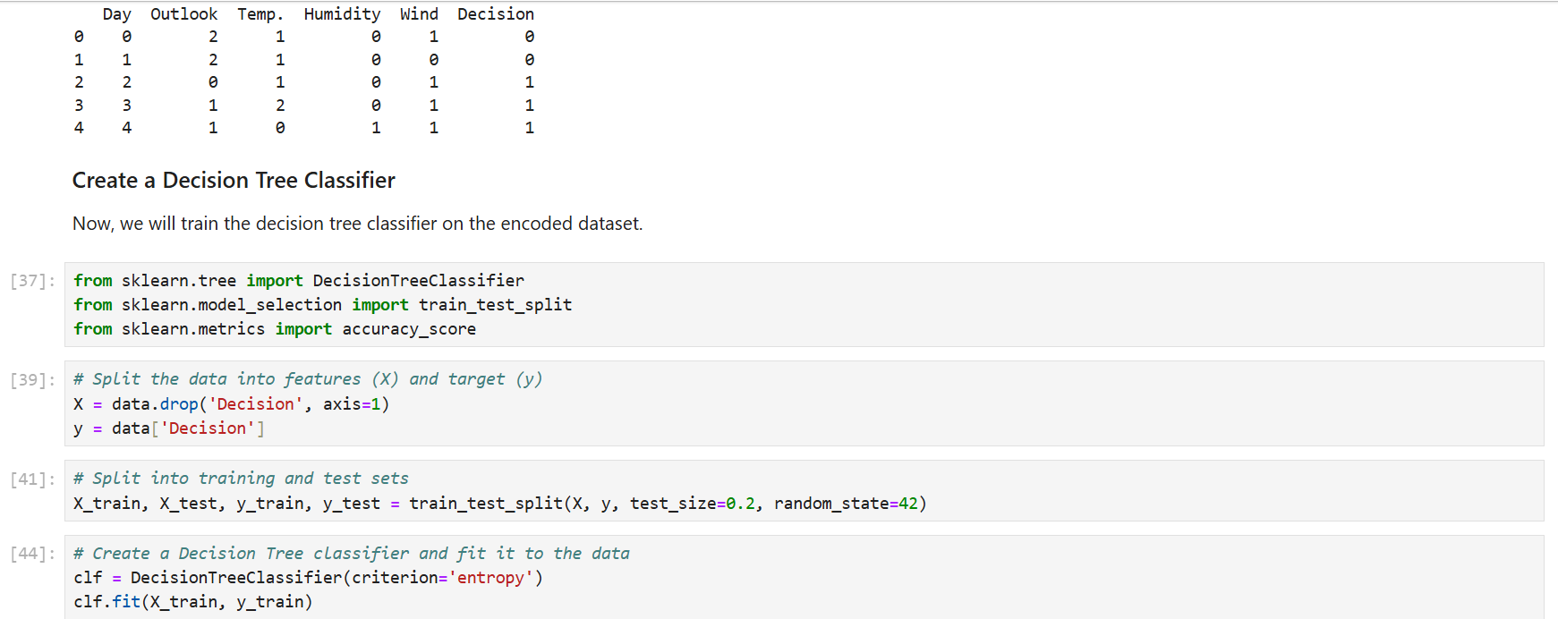

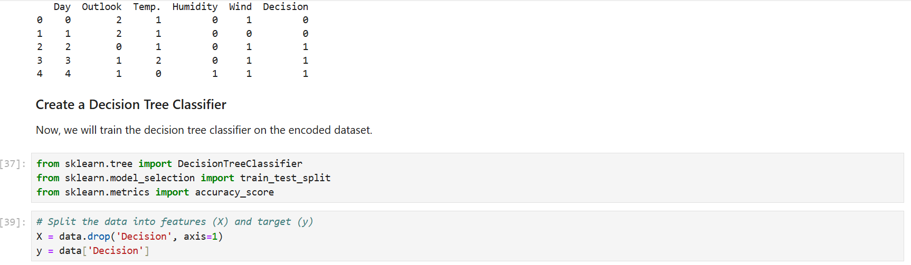

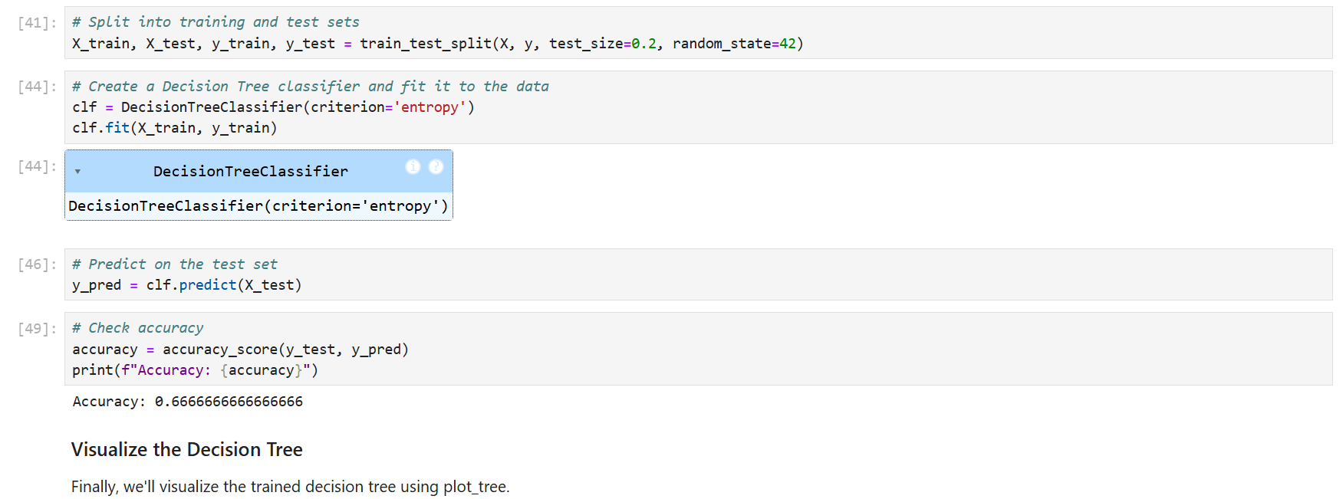

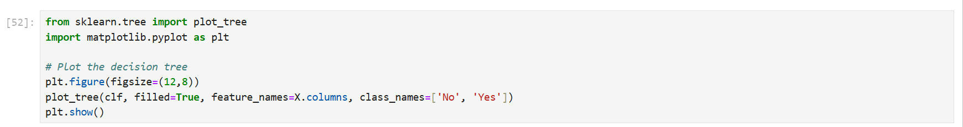

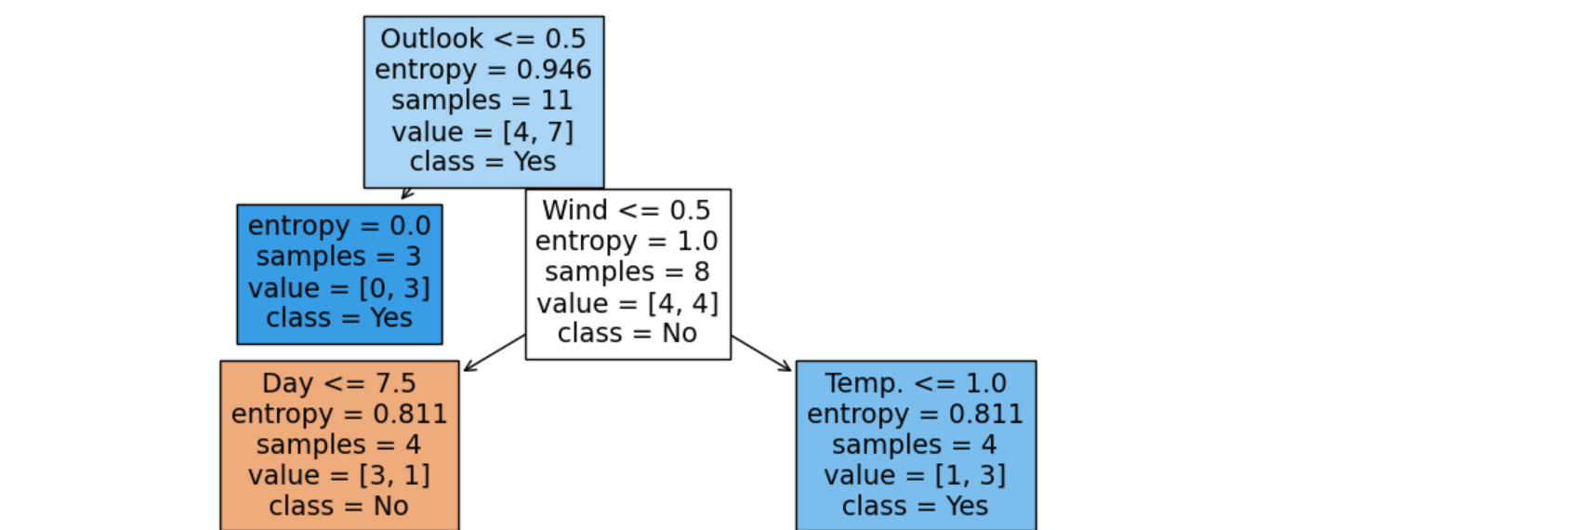

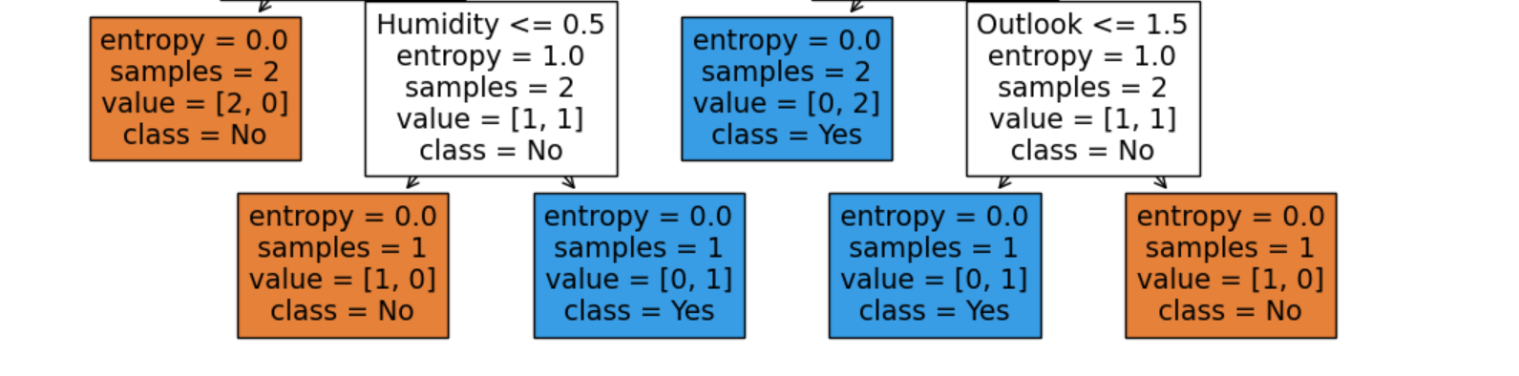

**QUESTION:3**

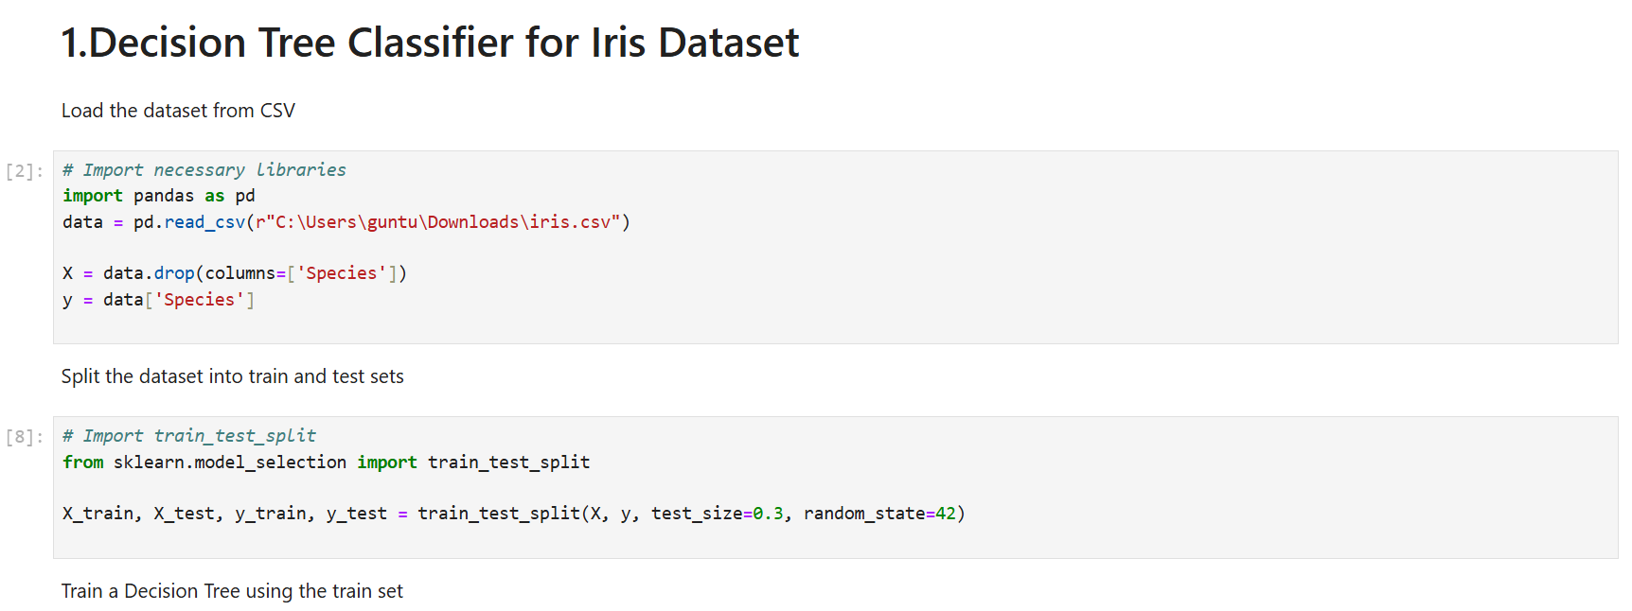

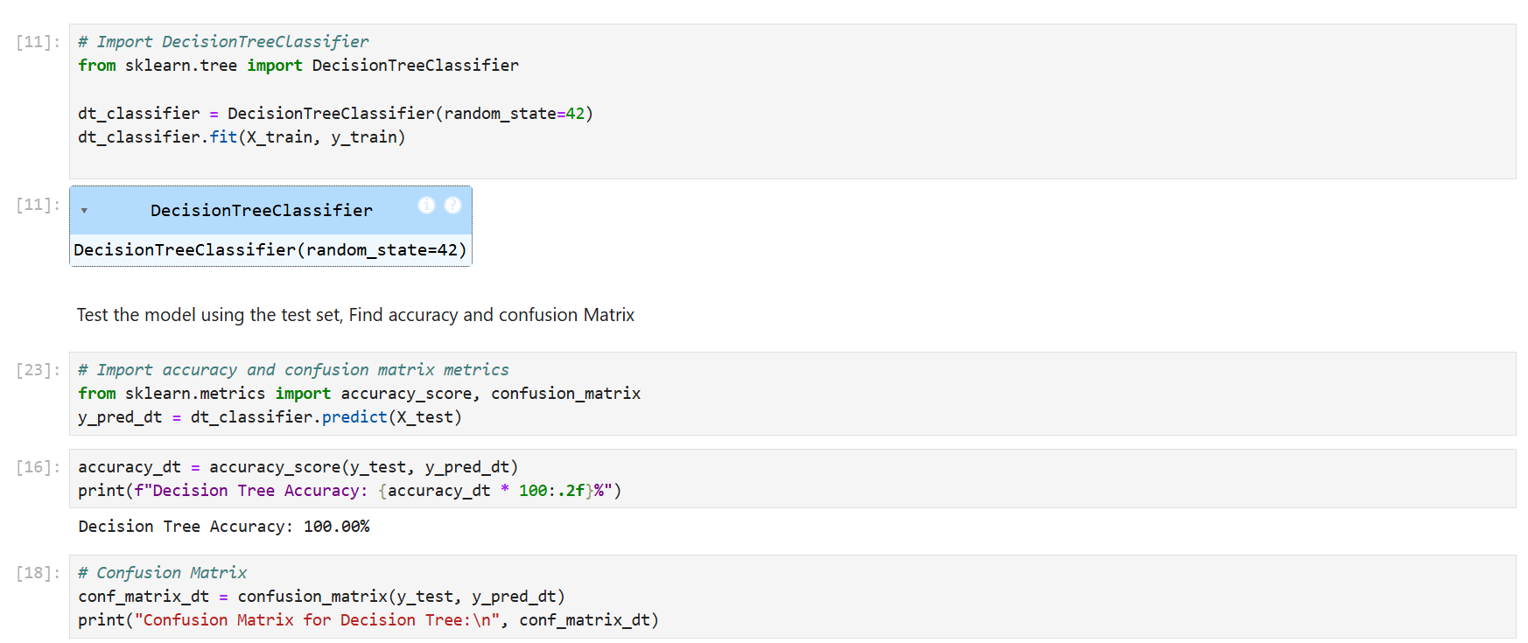



**QUESTION:4**

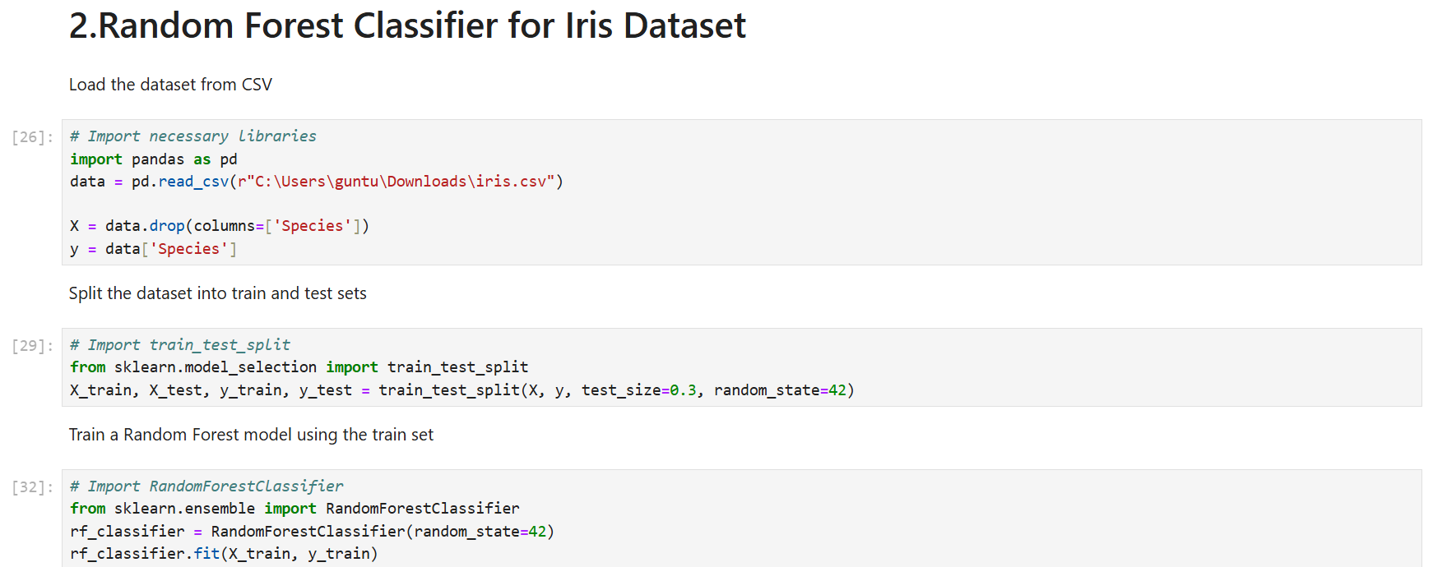

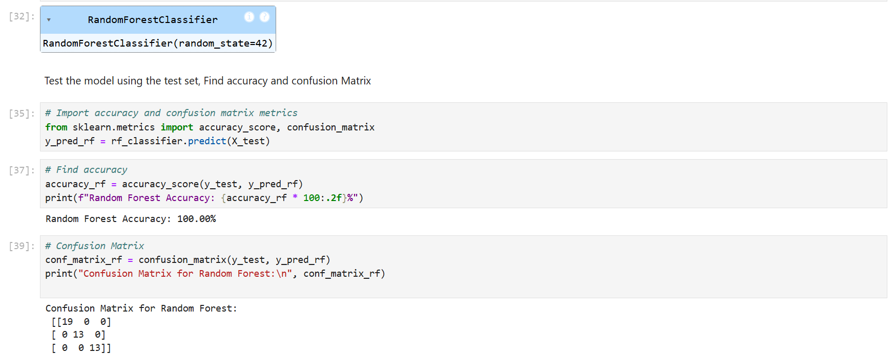

1. **Code Repository:**